Project Design Phase
Data Model Design
Date | 25 October 2025
Team ID | NM2025TMID02695
Project Name | Garage Management system
Maximum Mark | 4 Marks

4.1 Data Model Design
The GMS data model follows a hierarchical relationship structure connecting customer, appointment, service, and billing entities. This enables end-to-end traceability of every service performed within the garage.
4.1.1 Entity-Relationship Diagram (ERD)
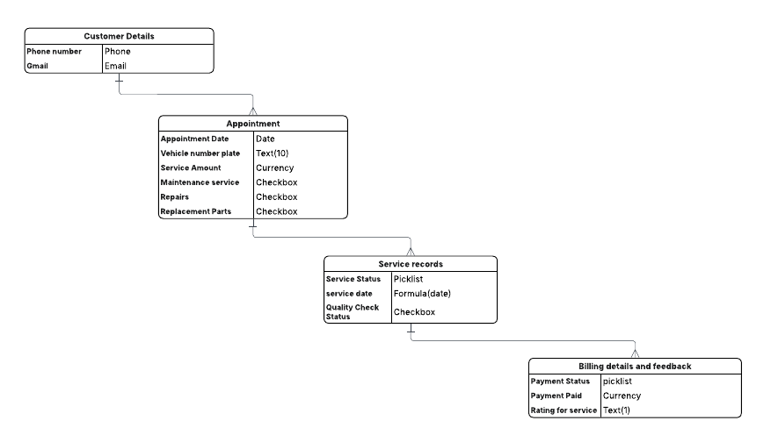

Relationship Flow Explanation:
- Customer Details → Appointment (Lookup Relationship):
  - One customer can have multiple appointments for different vehicles or service dates.
  - Implemented using a Lookup Relationship from Appointment to Customer Details.
- Appointment → Service Records (Lookup Relationship):
  - Each appointment can generate multiple service records based on work items (e.g., oil change, tire replacement).
  - This allows tracking each service independently.
- Service Records → Billing Details (Lookup Relationship):
  - A service record can have one or more associated billing entries to capture payments and ratings.
  - This supports financial closure and feedback collection.
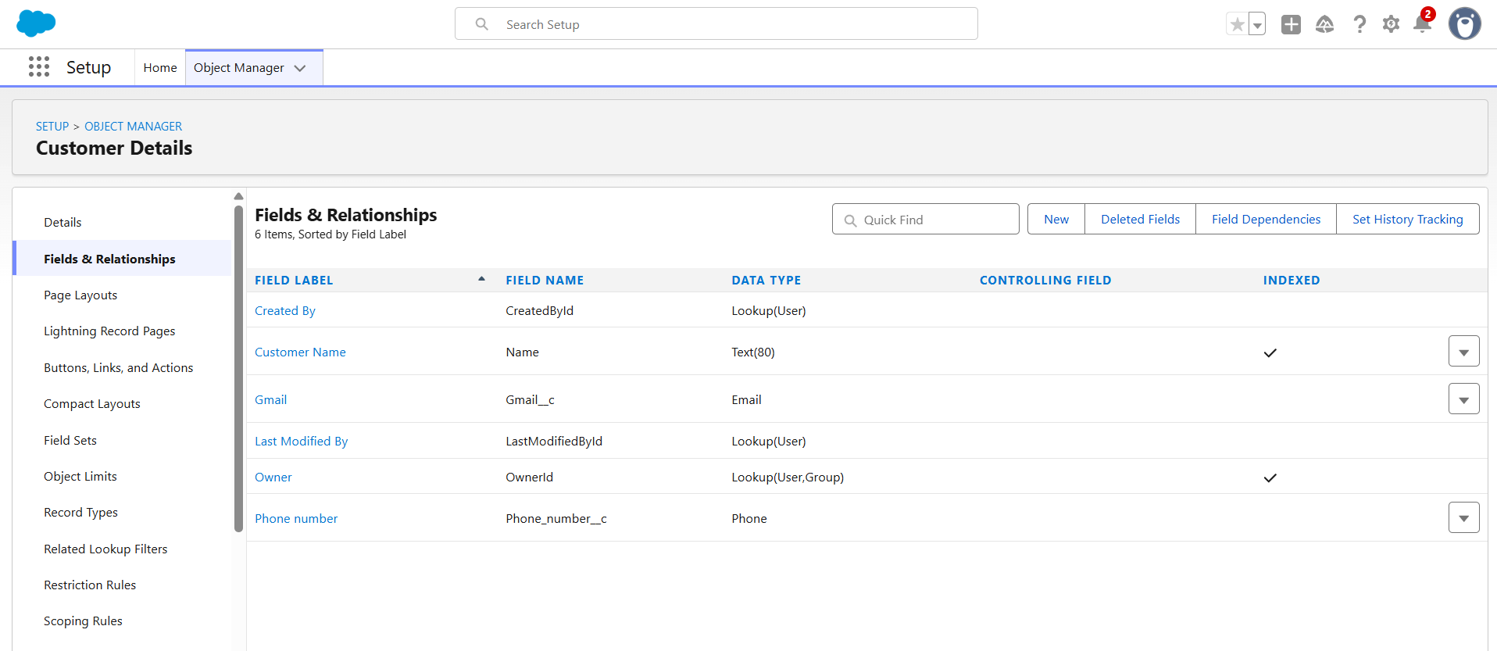
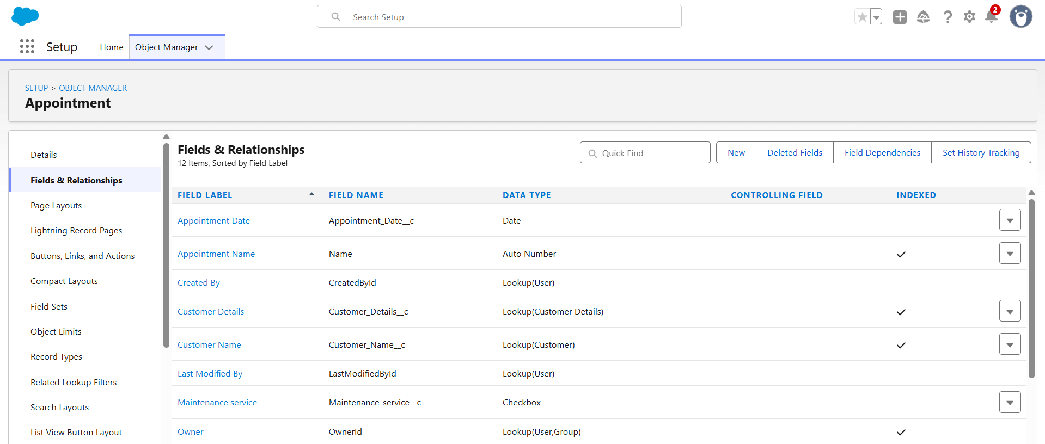
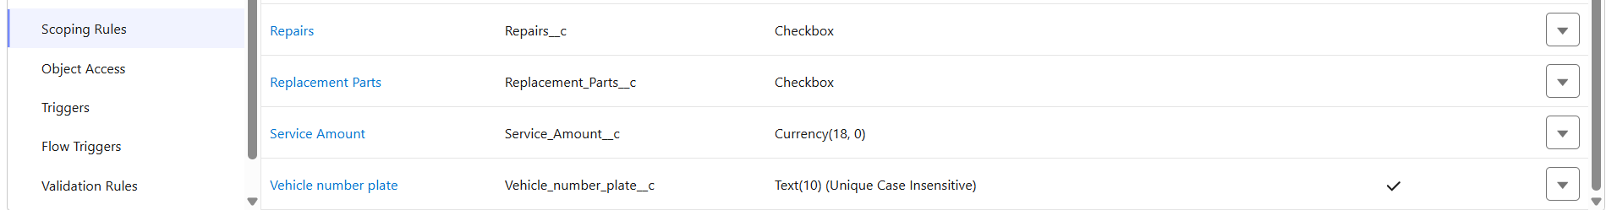

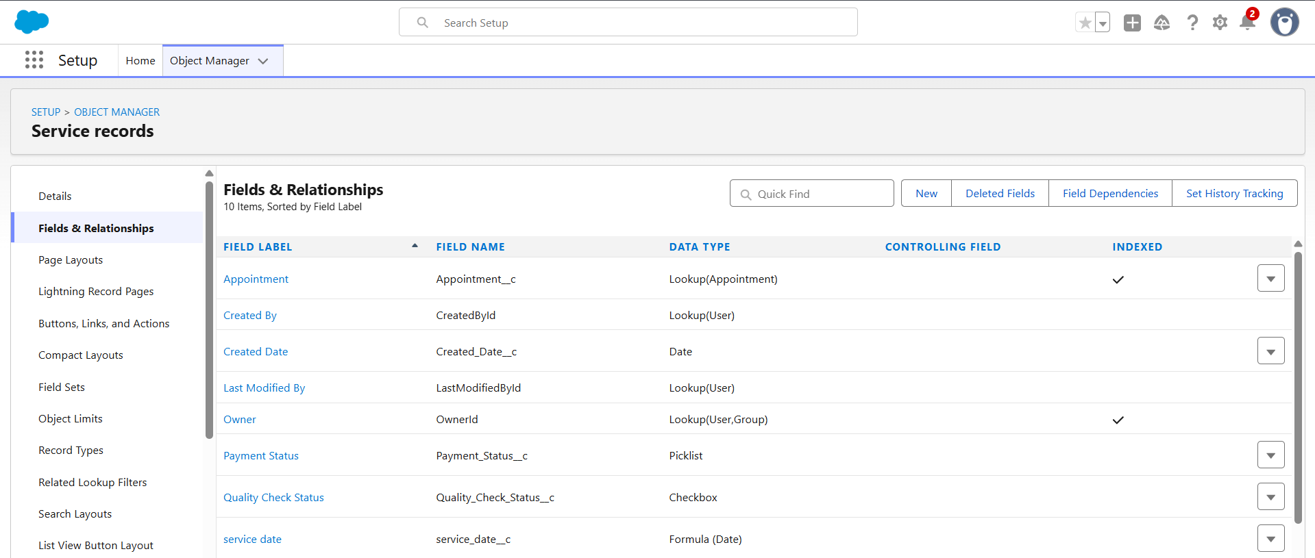
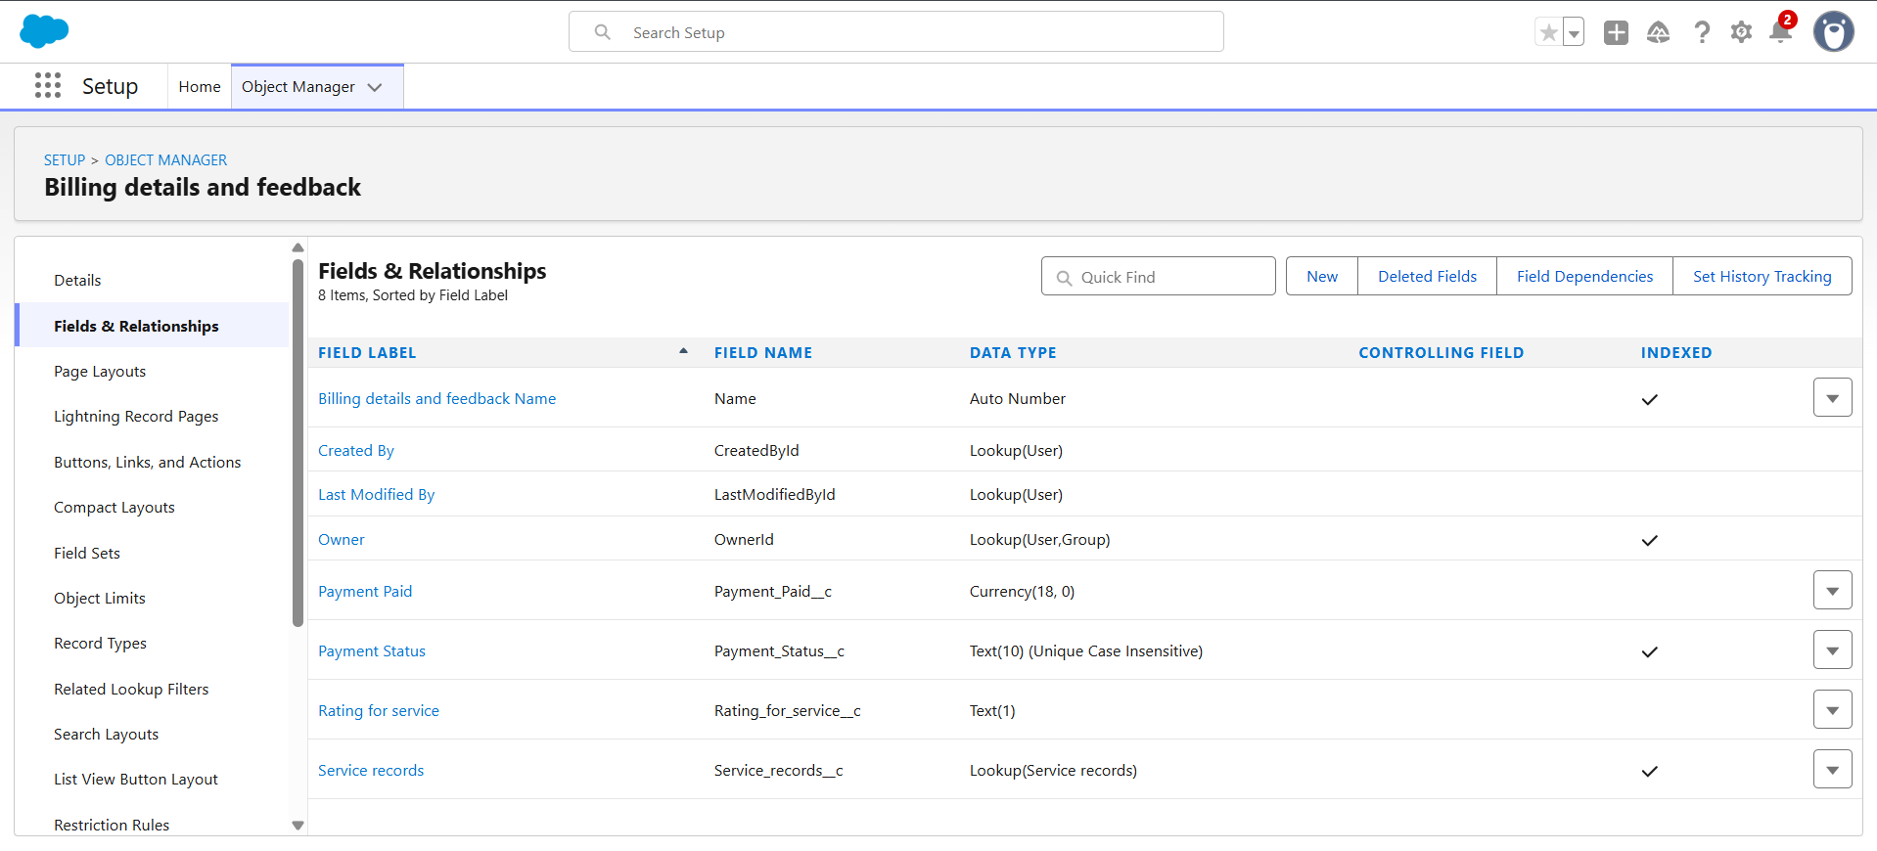4.1.2 Data Integrity Design
Ensuring accurate and consistent data is central to maintaining quality within GMS. Several Validation Rules, Lookup Filters, and Field-Level Constraints were implemented.
Control Type | Target Object | Purpose | Implementation Details
Validation Rule 1 | Appointment | Enforces the correct 10-character vehicle number plate format. | NOT(REGEX(Vehicle_number_plate__c, "[A-Z]{2}[0-9]{2}[A-Z]{2}[0-9]{4}"))
Validation Rule 2 | Billing Details | Ensures service rating is a single digit between 1 and 5. | NOT(REGEX(Rating_for_service__c, "[1-5]{1}"))
Validation Rule 3 (optional) | Service Records | Prevents record creation unless an Appointment is linked. | ISBLANK(Appointment__c)
Lookup Filter | Service Records → Appointment | Allows linking only valid appointments (scheduled in the past). | Appointment Date < TODAY()
Required Fields | Across all objects | Enforces data completeness. | Phone, Email (Customer); Vehicle No. (Appointment); Service Status (Service Records).

Integrity Rationale:
These controls ensure that all entered data adheres to real-world garage operation logic and prevents incomplete or inconsistent entries from affecting reporting accuracy.

